User manual for application to run our app:

Step 1: click on this click to go download the latest version of android studio.

<https://developer.android.com/studio>

step 2: After installing the latest version of android studio, launch the application and click configure.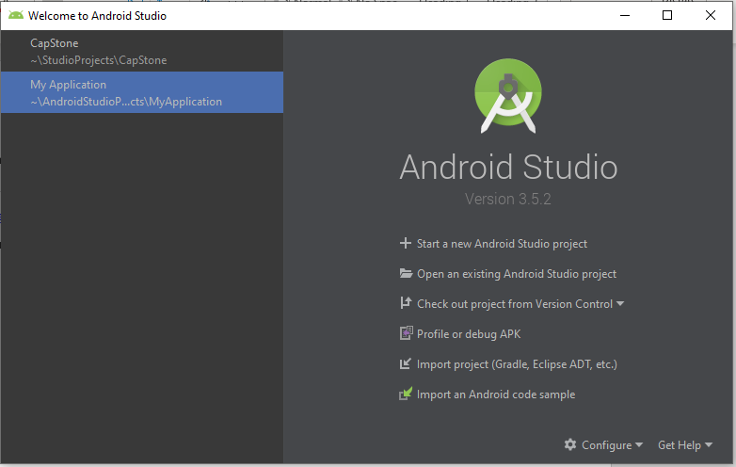

step 3: after clicking on configure, find a tap for git. Download the git.exe from the following link.

<https://git-scm.com/download/win> choose the right version for your computer configuration. Next find the folder where its save at and dins the git.exe file and copy the file path for it. Paste it onto the Path to Git executable then test the path. Once the path is correct continue to next step.

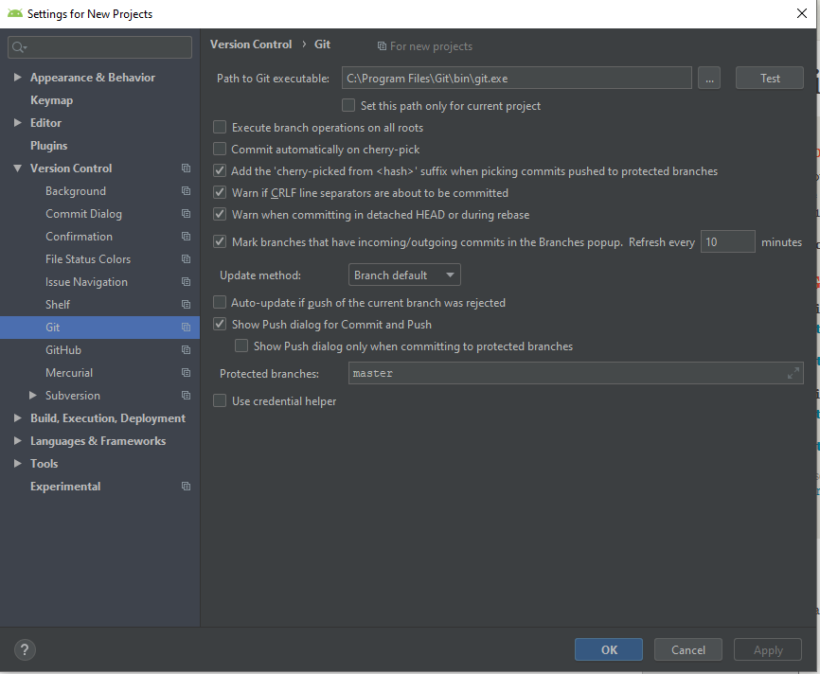

Step 4: click on Check out project from Version Control and select Git.

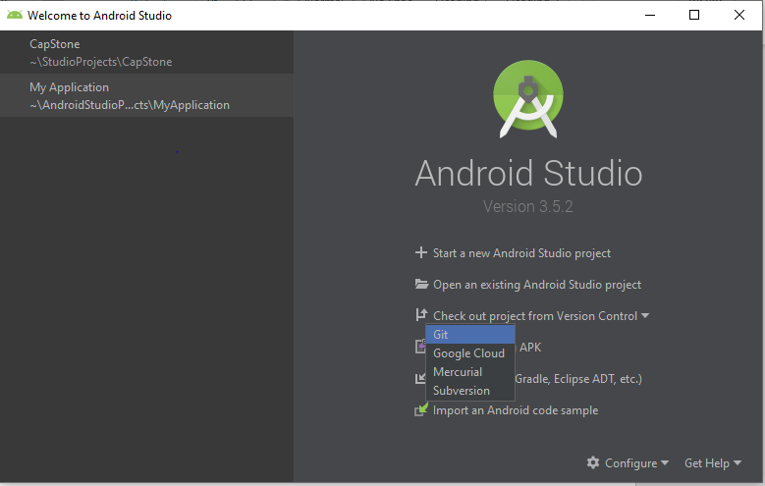

Step 5: once on this page past the URL of our group project on the URL tap and press clone. This step will take some time to get our project from GitHub repository.

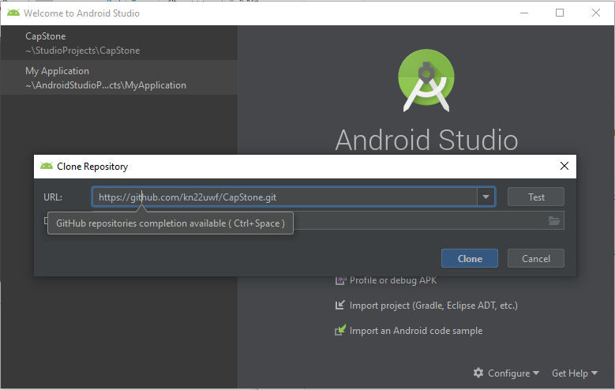

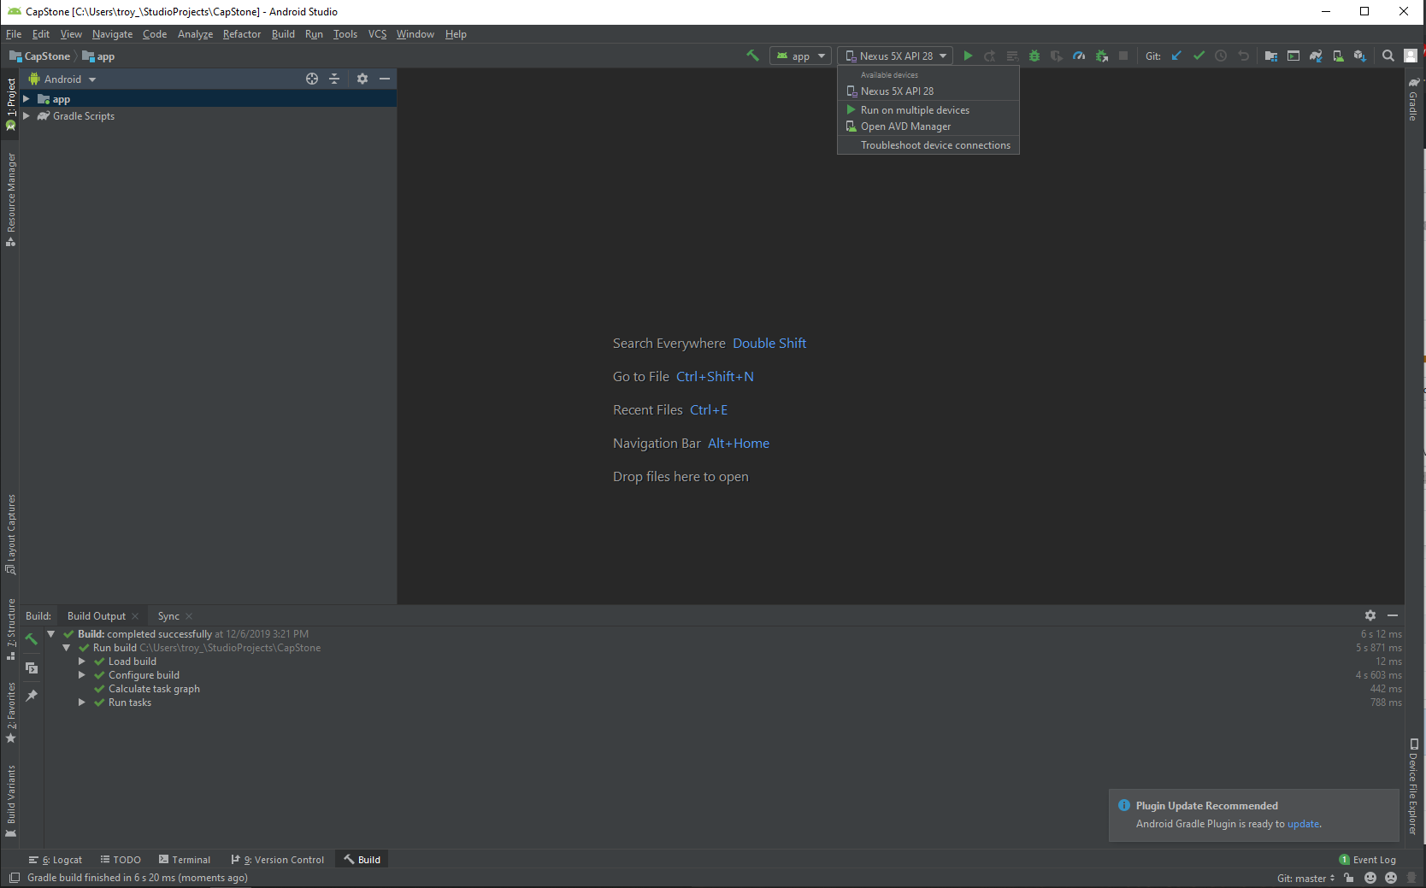Step 6: After android studio is finish with cloning the project click on where is red circle is to create an emulator to run our project on. Open AVD Manager

Step 7: once the emulator is created. Click on the play button and wait for the emulator to start up and our application will be running on it.

